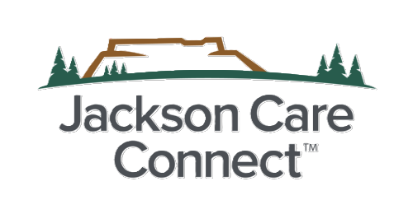
JCC Community Grant Application JCC 2026

1. Organization Name (required) *
Organization or Fiscal Sponsor Legal Name

2. Primary Contact Name *

Primary Contact Email *

Primary Contact Phone

Mailing Address

City

State
3. Is your organization an SDOH-E partner under OHA definitions?* select yes or no

*(A single organization, local government, one or more Nine Federally Recognized Tribes of Oregon, the Urban Indian Health Program, or a collaborative, that delivers
social determinants of health and health equity (SDOH-E) related services or programs, or supports policy and systems change, or both, within a CCO’s service area. Clinical partners who are addressing health disparities by improving health care access and quality are also considered SDOH-E partners for SHARE.
Source: OAR 410-141-3735)
4. Organization Type please select:
Nonprofit, Tribal Government/Entity, School District, Federally Qualified Health Center, Culturally Specific CBO, Collaborative (requires fiscal sponsorship)

Project Summary
5. Project Title *
6. Amount Requested *
(up to $25,000)
7. Please provide a high-level description of your project. *

8. Project Type (select all that apply)
Program/Service
Capacity Building
Equipment/Capital
Workforce/Training
Policy/Systems Change
SHARE Eligibility
9. SDOH-E Domain(s) Addressed (select at least one)
Economic Stability
Neighborhood & Built Environment
Education
Social and Community Health
Healthcare Access & Quality
10. Does your project directly address housing-related services/supports?
If yes, please describe.
11. Compliance Attestation- Project does NOT include Medicaid-covered benefits, HRS/HRSN covered services, ILOS, general CCO operations, political contributions, restricted advocacy, or CCO marketing. *
Check if true and correct
CHIP Alignment
12. CHIP Priority this Project Supports *
Select at least one:
Housing
Behavioral Health
Community Building
Access to Healthcare
13. Describe how your project aligns with this CHIP priority. *
Please visit allin4health.org to review the plan.

14. Select the priority population(s) this project will support. *
Children/Youth
Families
Older Adults
Communities of Color
Tribal Communities
Immigrants/Refugees People Experiencing Houselessness
Rural Communities
LGBTQIA2S+
Low-income
Other
Activities and Outcomes
List the key activities of this project *
Bulleted-list preferred

What are the Expected Outcomes of this project? *
(1-3 short and long-term changes)

What is the timeline of this project? *
Start Date- End Date
Section 6: Budget
Section 6: Budget
Please complete the budget workbook linked on the grant application page and attach to this form in question 20.
19. Budget Narrative *
(2-4 sentences)

